3D viewing

In 2D we specify a window on 2D world and a view port on 2D view surface
objects in world are clipped against window and are then transformed into view port for display.

Added complexity caused by
i. added dimension
ii. display devise are only 2D
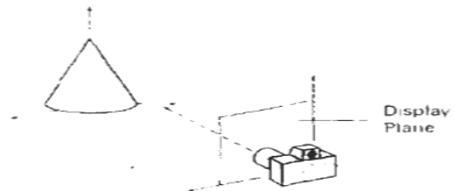

Solution is accomplished by introducing projections that transform 3D objects onto 2D plane

In 3D we specify view volume(only those objects within view volume will appear in display on output device others are clipped from display) in world , projection onto projection plane and view port on view surface

So objects in 3D world are clipped against 3D view volume and are then projected
the contents of projection of view volume onto projection plane called window are then transformed (mapped onto ) view port for display.

Projections
Transform points in coordinate system of dimension ‘n’ into points in a coordinate system of dimension less than ‘n’.

Projection of 3D object is defined by straight projection rays(projectors) emanating from center of projection, passing thru each point of object and intersecting a projection plane to form projection.

These are planar geometric projection as the projection is onto a plane rather than some curved surface and uses straight rather than curved projectors.

2 types of projections
i. distinction is in relation of center of projection to projection plane

ii. if the distance from one to other
is finite then projection is perspective

iii. if the distance is infinite then projection is parallel.

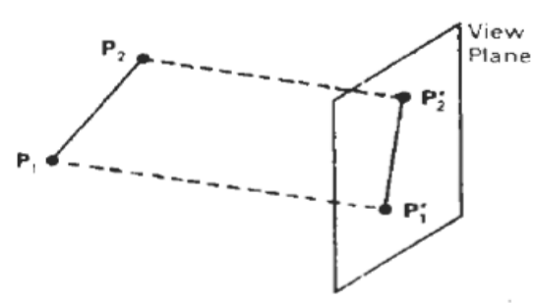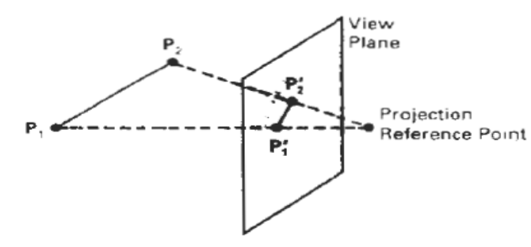

Perspective
A perspective projection whose center is
a point at infinity becomes a parallel projection

Visual effect of perspective projection is similar to that of photographic system and human visual system.

Size of perspective projection of an object varies inversely with distance of that object from the center of projection

Although objects tend to look realistic, is not particularly useful for recording exact shape and measurements of objects.

Perspective projection of any set of parallel lines that are not parallel to projection plane converge to vanishing point

In 3D parallel lines meet only at infinity

If the set of lines parallel to one of three principal axes then vanishing point is called axis vanishing point

eg. If projection plane cuts only z axis and normal to it , only z axis has principle vanishing point as lines parallel to either y or x axes are also parallel to projection plane and has no vanishing points
In fig lines parallel to x,y do not converge only lines parallel to z axis converge

Parallel

Coordinate positions are transformed to the view plane along parallel lines
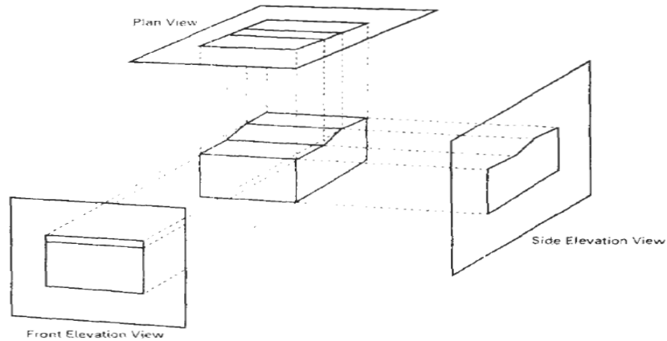

Preserves relative proportions of objects so that accurate views of various sides of an object are obtained but doesn’t give realistic representation of the 3D object.

Can be used for exact measurements so parallel lines remain parallel.
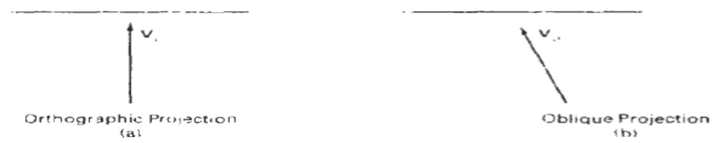

- Orthographic parallel projection

When projection is perpendicular to view plane we have orthographic parallel projection.

Used to produce the front, side and top views of an object. Front, side and rear
orthographic projections of an object are called elevations

Top orthographic projection Is called a
plan view.

Used in Engineering and architectural drawings.

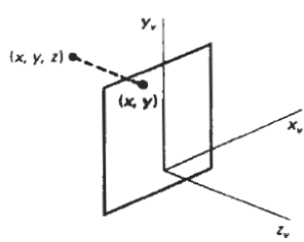

Views that display more than one face of an object are called axonometric orthographic
projections. Most commonly used axonometric projection is the isometric projection.

Transformation equations
If view plane is placed at position z_{vp} along z_{v} axis then any point (x,y,z) is
transformed to projection as
x_{p} = x , y_{p} = y
z value is preserved for depth information needed (visible surface detection).

y_{v}

(x_{p},y_{p})
x_{v}
- Oblique parallel projection
α
(x,y,z)

Obtained by projecting points along parallel
L
lines that are not perpendicular to projection plane.
Θ
(x,y)
Often specified with two angles Θ and α
Point (x ,y ,z) is projected to position(x_{p} , y_{p} ) on the view plane
Orthographic projection coordinated on the plane are (x,y).
View Plane
Oblique projection line from (x,y,z) to (x_{p} , y_{p} ) makes an angle
with then line on the projection
plane that joins (x_{p} , y_{p} ) and (x , y)
z_{v}

This line of length L is at an angle Θ with the horizontal direction in the projection plane.
Expressing projection coordinates in terms of x,y,L and Θ as
x_{p} = x + LcosΘ
y_{p} = y + LsinΘ
L depends on the angle α and z coordinate of point to be projected
tan α = z/L
thus,
L = z/tan α
= zL₁ L₁ is the inverse of tanα
so the oblique projection equations are
x_{p} = x + z ( L₁cosΘ )
y_{p} = y + z ( L₁sinΘ )
the transformation matrix for producing any parallel projection onto the
x_{v} y_{v} plane can be written as

1 0 L₁cosΘ 0
0 1 L₁sinΘ 0
M_{parallel} = 0 0 0 0
0 0 0 1

Orthographic projection is obtained when L₁ ₌ 0 (occurs at projection angle α of 90*)
Oblique projection is obtained with non zero values for L_{1.}

